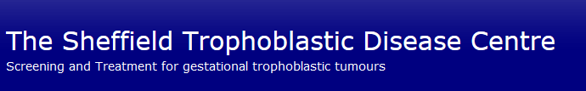

Charing Cross Hospital Trophoblast Disease Service
Trophoblastic Tumour Screening and Treatment Centre
Department of Medical Oncology
Charing Cross Hospital
Fulham Palace Road
LONDON W6 8RF
UK
Tel: 020 3311 1409
Fax: 020 3313 5577
Email: hmole-chorio@imperial.nhs.uk

Scottish Hydatidiform Mole Follow-up Service
Ninewells Hospital
Dundee
DD1 9SY
Tel: 01382 632748
Email: hmolescotland.tayside@nhs.net

